Planning phase

Contents

- Hold project kick off meeting
- Develop work plan
  - Develop work breakdown structure (WBS)
  - Develop project staffing plan
  - Develop project schedule
  - Develop project budget
- Develop project control plan
  - Communications plan
  - Quality management plan
  - Issue Management Plan
  - Change Management Plan
  - Risk Management Plan
  - Procurement Plan
  - Support Transition Plan
- Finalize Project Plan and gain approvals

Project Kickoff Meeting: Agenda

- Introductions (optional, if members are acquainted)

- Charter Review
  - Discuss the approved Project Charter
  - Clarify the charter through questions/answers

- Discuss Next Steps for Stakeholders
  - Read minutes and contribute additions/corrections
  - Provide input for the Work Plan and Control Plan
  - Review Project Plan at a future meeting

Work Breakdown Structure outline:

Task Name
start
Mobility
finding office
landscape
utility connections "water and electricity"
delivering computers
Recruitment
managers
developers
testers
designers
Buses network planning
ordering buses and delivery
Drivers Recruitment
buses routes planning
Buses launching
drivers training on routes
starting buses trips
ordering taplets and delivery
Designing
designing website
designing application
Developing
website
frontend
backend
IOS application
fontend
backend
android application
forntend
backend
Testing
website
android application
IOS application
drivers training on how to use the system
Launching
website
IOS application
android application
close

Work breakdown structure diagram:
This is the corresponding WBS diagram and I have attached an image and PDF for high quality
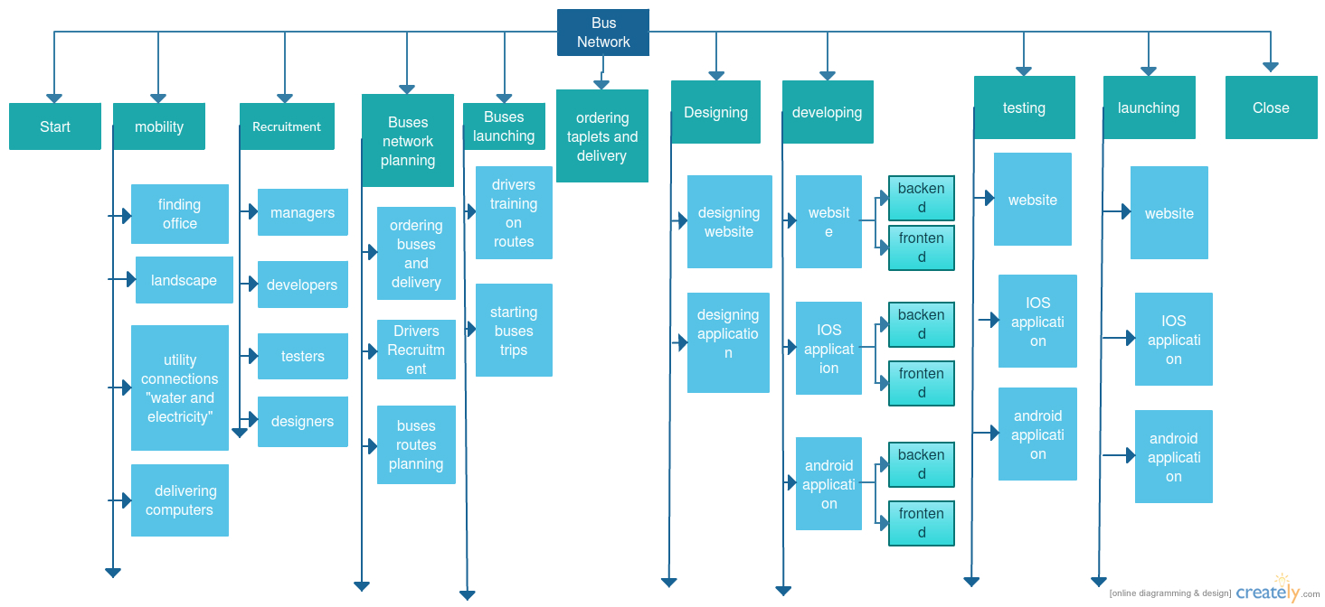

Staffing Plan

Role Requirements

Role | Project Responsibility | Skills Required | # of persons | Estimated start date | Duration Required  FYyy-yy
Project manager | management | Project management | 1 | From the start of the project | The end of the project
Drivers manager | Solve drivers problems | Good communication skills | 1 | 15/11/2017 | forever
Designer | design website and mobile app. | Web design | 2 | 2/7/2017 | One month
tester | Testing the two applications | Problem solving and troubleshooting | 2 | 1/1/2018 | One month
Developers | Developing the website and the mobile application. | Can work with web, IOS and android. | 3 | 1/8/2017 | 8 months
Sales | Buying all required components, making deals and receiving them. | Can get good offers and high quality.  Honest. | 1 | From the start of the project | Till the end of the project
Developing manager | He is the supervisor of the software team. | Can manage people.  Knows about software developing. | 1 | From the start of the project | Till the end of the project

Staff Assigned to Roles

Role | Name | Requested  FTE  FYyy-yy | Acquired FTE  FYyy-yy | Rate | Rate Unit
Project manager | Yomna Alaa | 30000 | 20000 | 1000 | day
Drivers manager |  | 10000 | 7000 | 350 | day
Designer |  | 15000 | 10000 | 500 | day
Tester |  | 10000 | 7000 | 350 | day
Developers |  | 15000 | 10000 | 500 | day
Sales |  | 15000 | 10000 | 500 | day
Developing manager |  | 20000 | 17000 | 850 | day

Staff Resource Loading Chart

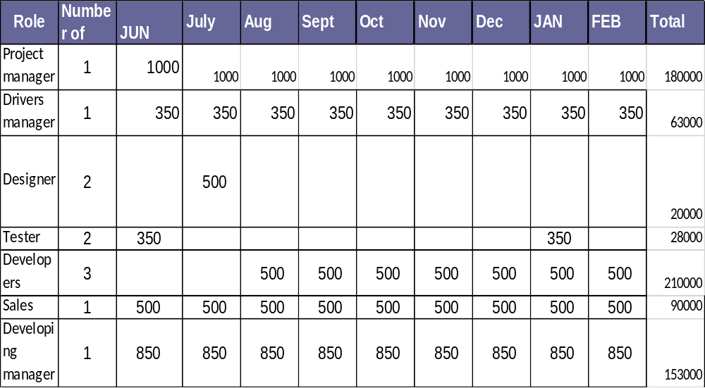

Training Needs

Role/Staff Resource | Training Need | Timeframe Needed
Drivers | Knowing the routes and how to treat with the buses | 7 days
Drivers | How to use the system efficiently | 10 days

PROJECT ORGANIZATION CHART

Drivers manager

Project manager

Developing manager

Sales man

Web Developer

Mobile developer

tester

designer

Project Schedule:

WBS | Task Name | Duration | Start | Finish | Resource Names
1 | start | 1 day | Thu 6/1/17 | Thu 6/1/17
2 | Mobility | 13 days | Thu 6/1/17 | Mon 6/19/17
2.1 | finding office | 3 days | Thu 6/1/17 | Sat 6/3/17
2.2 | landscape | 4 days | Mon 6/5/17 | Thu 6/8/17
2.3 | utility connections "water and electricity" | 6 days | Fri 6/9/17 | Fri 6/16/17
2.4 | delivering computers | 4 days | Wed 6/14/17 | Mon 6/19/17 | Sales
3 | Recruitment | 10 days | Sun 6/18/17 | Thu 6/29/17
3.1 | managers | 5 days | Sun 6/18/17 | Thu 6/22/17
3.2 | developers | 5 days | Sun 6/25/17 | Thu 6/29/17 | Project manager ,Developing manager
3.3 | testers | 5 days | Sun 6/25/17 | Thu 6/29/17 | Project manager ,Developing manager
3.4 | designers | 5 days | Sun 6/25/17 | Thu 6/29/17 | Project manager ,Developing manager
4 | Buses network planning | 120 days | Thu 6/15/17 | Wed 11/29/17
4.1 | ordering buses and delivery | 6 mons | Thu 6/15/17 | Wed 11/29/17 | Sales
4.2 | Drivers Recruitment | 7 days | Wed 11/15/17 | Thu 11/23/17 | Drivers manager
4.3 | buses routes planning | 1 mon | Tue 8/1/17 | Mon 8/28/17 | Project manager
5 | Buses launching | 8 days | Sun 12/3/17 | Tue 12/12/17
5.1 | drivers training on routes | 7 days | Sun 12/3/17 | Sun 12/10/17 | Buses[1],Drivers manager
5.2 | starting buses trips | 1 day | Tue 12/12/17 | Tue 12/12/17 | Buses[1],Drivers manager
6 | ordering taplets and delivery | 1 mon | Sun 10/22/17 | Thu 11/16/17 | Sales
7 | Designing | 20 days | Sun 7/2/17 | Thu 7/27/17
7.1 | designing website | 1 mon | Sun 7/2/17 | Thu 7/27/17 | Designer
7.2 | designing application | 1 mon | Sun 7/2/17 | Thu 7/27/17 | Designer
8 | Developing | 108 days | Tue 8/1/17 | Thu 12/28/17
8.1 | website | 43 days | Tue 8/1/17 | Thu 9/28/17 | computers[1],Developers
8.1.1 | frontend | 1 mon | Tue 8/1/17 | Mon 8/28/17 | computers[1],Developers
8.1.2 | backend | 1 mon | Tue 8/29/17 | Mon 9/25/17 | computers[1],Developers
8.2 | IOS application | 43 days | Sun 10/1/17 | Tue 11/28/17 | computers[1],Developers
8.2.1 | fontend | 1 mon | Tue 9/26/17 | Mon 10/23/17 | computers[1],Developers
8.2.2 | backend | 1 mon | Wed 11/1/17 | Tue 11/28/17 | computers[1],Developers
8.3 | android application | 42 days | Wed 11/1/17 | Thu 12/28/17 | computers[1],Developers
8.3.1 | forntend | 1 mon | Wed 11/1/17 | Tue 11/28/17 | computers[1],Developers
8.3.2 | backend | 1 mon | Sun 12/3/17 | Thu 12/28/17 | computers[1],Developers
9 | Testing | 24 days | Mon 1/1/18 | Thu 2/1/18 | computers[1]
9.1 | website | 7 days | Mon 1/1/18 | Tue 1/9/18 | computers[1],Tester
9.2 | android application | 7 days | Wed 1/10/18 | Thu 1/18/18 | computers[1],Tester
9.3 | IOS application | 7 days | Sun 1/21/18 | Sun 1/28/18 | computers[1],Tester
9.4 | drivers training on how to use the system | 10 days | Sun 1/21/18 | Thu 2/1/18 | tablets[1],Buses[1],Tester
10 | Launching | 13 days | Sun 2/4/18 | Tue 2/20/18
10.1 | website | 3 days | Sun 2/4/18 | Tue 2/6/18 | tablets[1],servers[1],Developers ,Tester
10.2 | IOS application | 4 days | Wed 2/7/18 | Sun 2/11/18 | tablets[1],servers[1],Developers ,Tester
10.3 | android application | 3 days | Mon 2/12/18 | Wed 2/14/18 | tablets[1],servers[1],Developers ,Tester
11 | close | 1 day | Thu 3/1/18 | Thu 3/1/18

Network Diagram:
That it is impossible to screenshot the whole diagram so it is divided into many pictures
First this is the whole diagram but without any details:

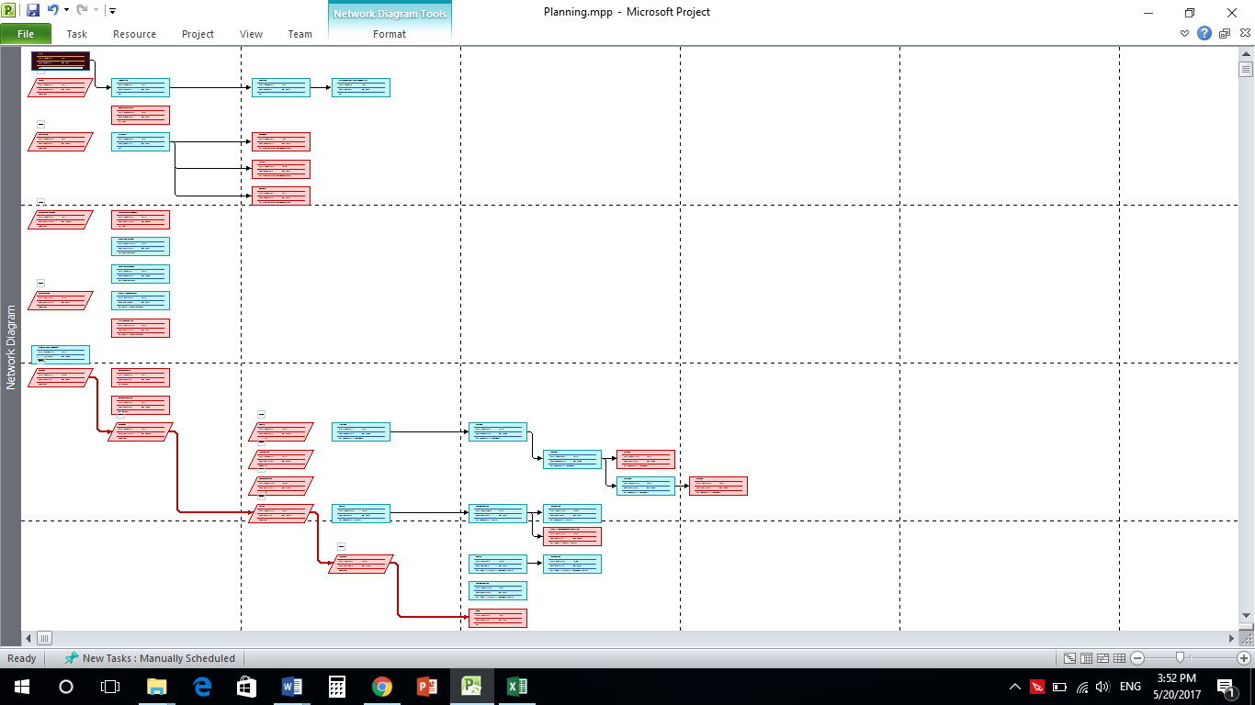

And then these are the details of the diagram:

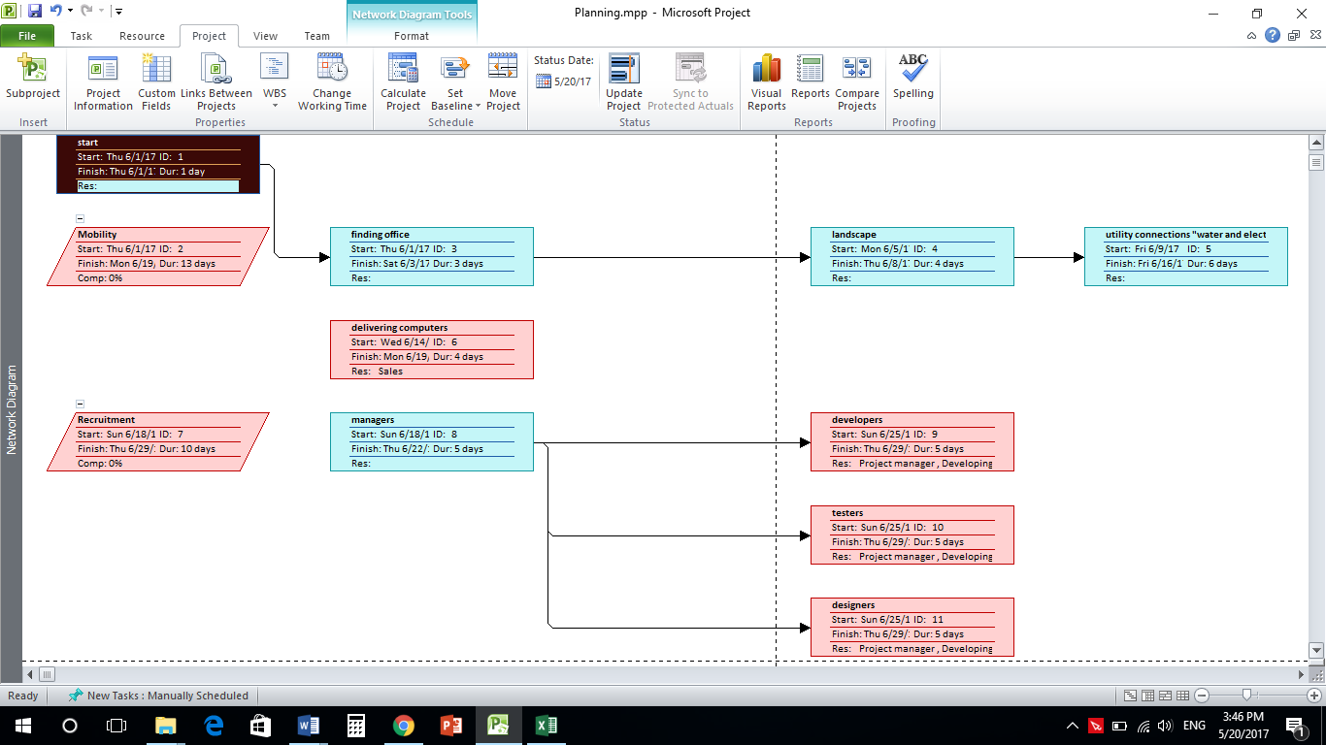

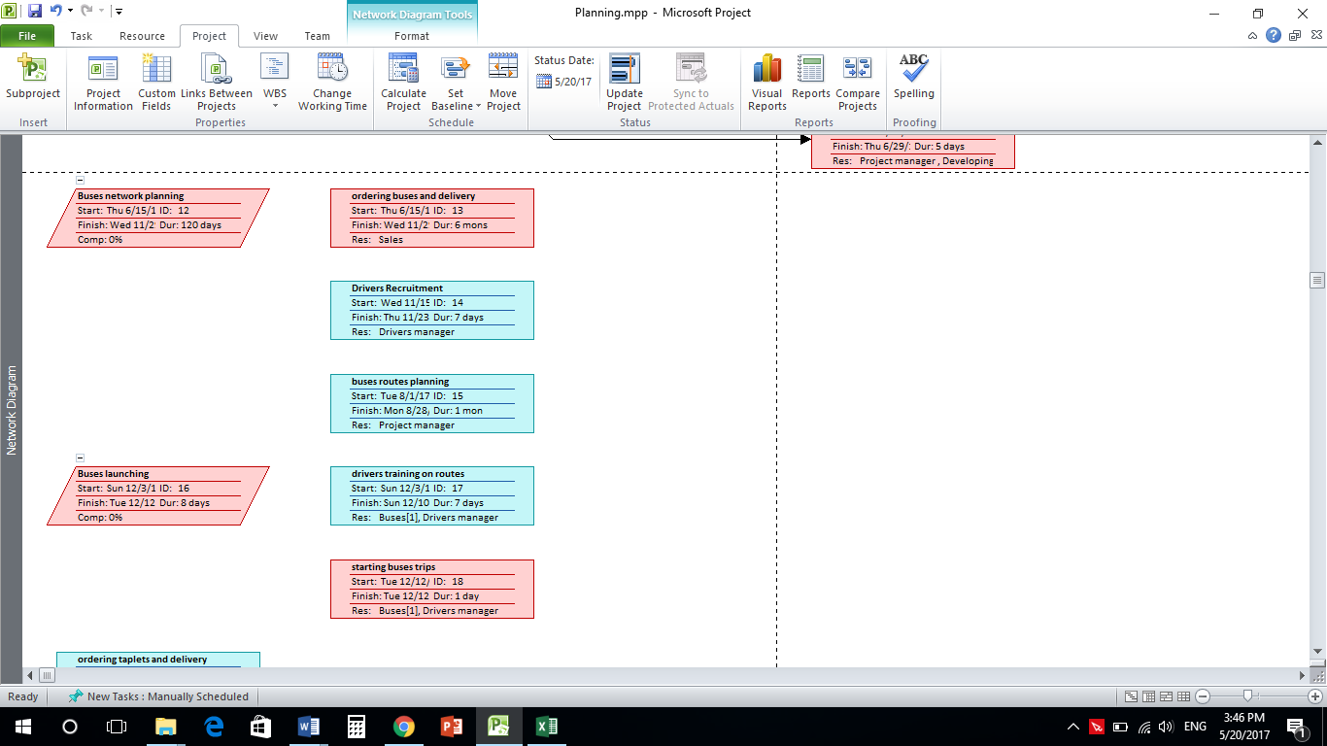

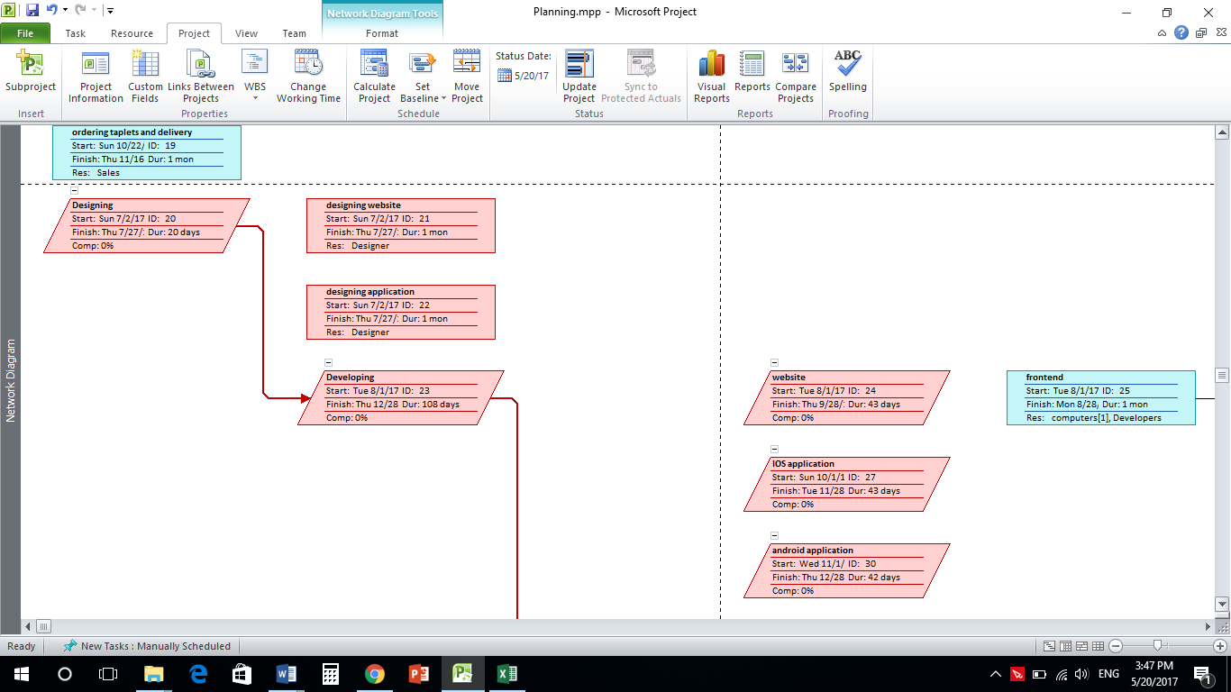

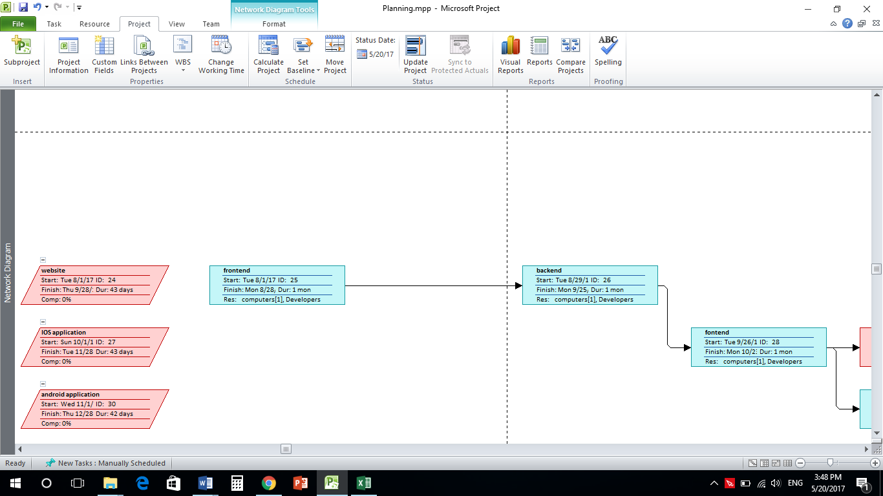

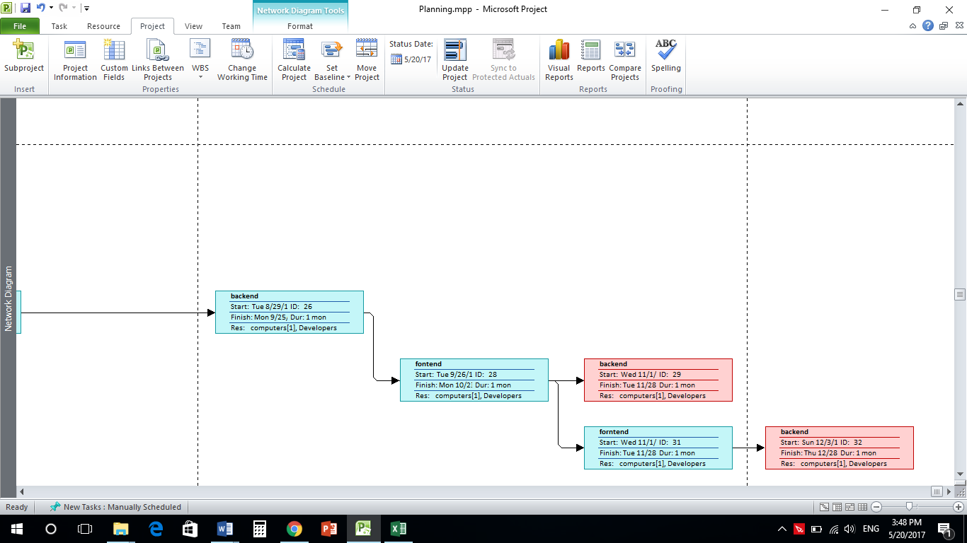

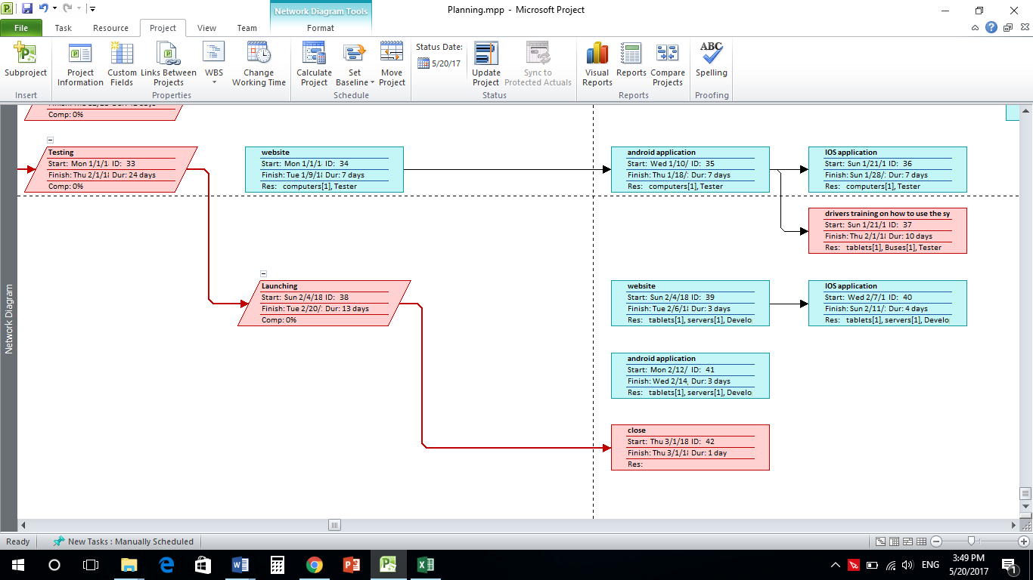

Gantt Chart:

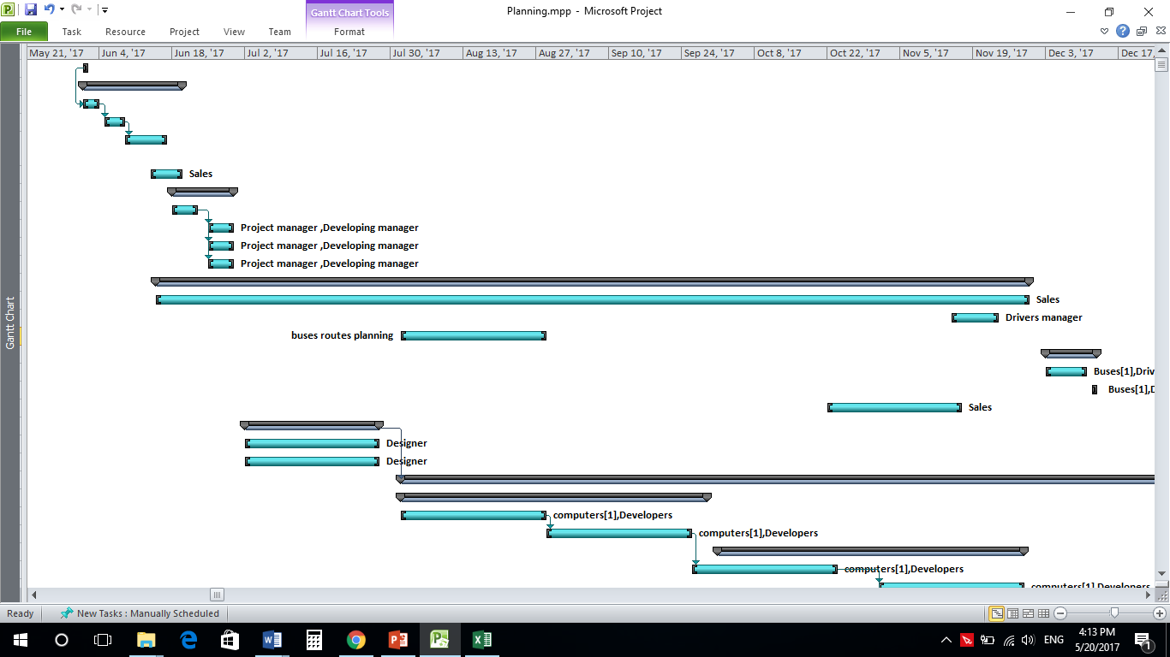

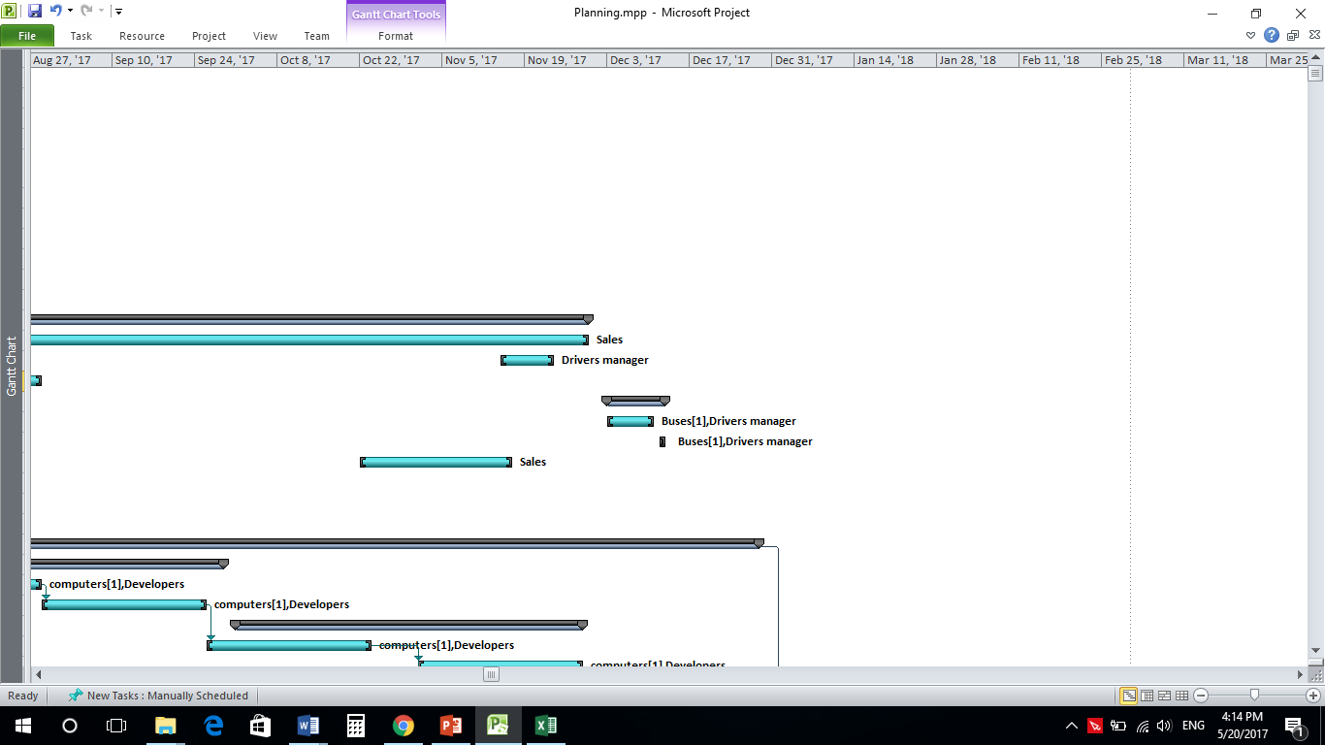

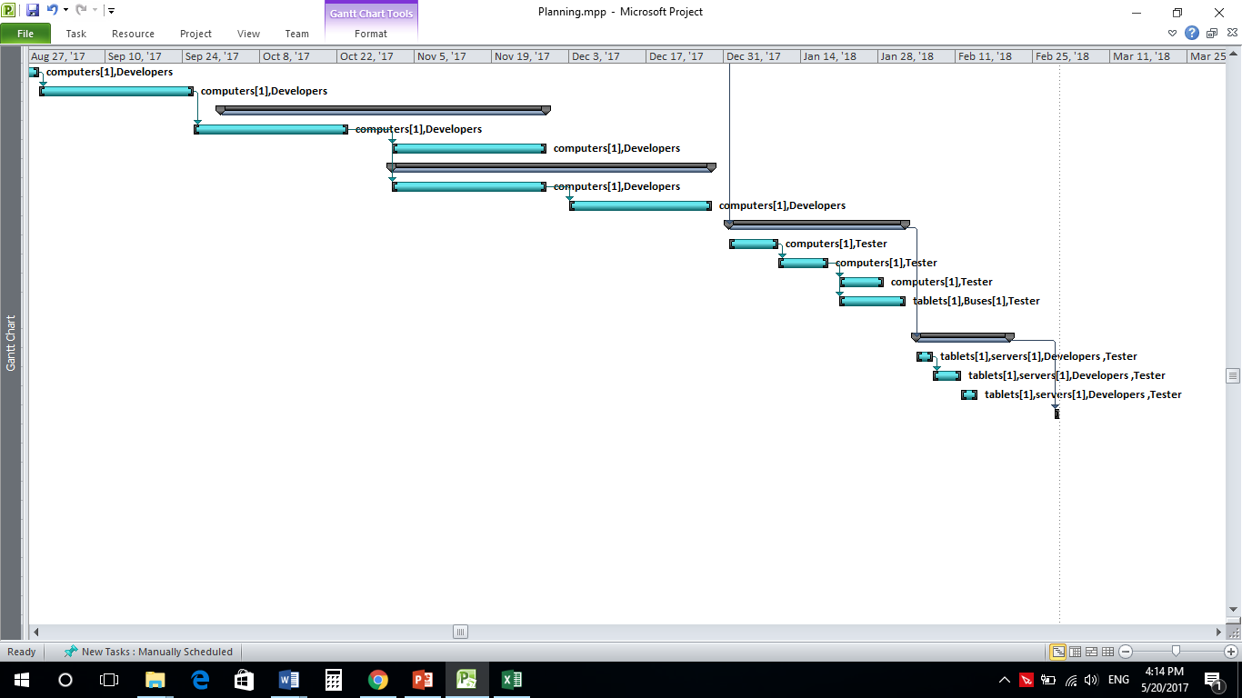

Project Budget

Budget during the life of the Project

Line Item | FY05-06
 | Labor | Material | Other | Cost
start | 2,700.00 ج.م.‏ |  |  | 2,700.00 ج.م.‏
Mobility | 35,100.00 ج.م.‏ |  |  | 35,100.00 ج.م.‏
finding office |  |  |  | 0.00 ج.م.‏
landscape |  |  |  | 0.00 ج.م.‏
utility connections "water and electricity" |  |  |  | 0.00 ج.م.‏
delivering computers |  |  |  | 0.00 ج.م.‏
Recruitment | 27,000.00 ج.م.‏ |  |  | 27,000.00 ج.م.‏
managers |  |  |  | 0.00 ج.م.‏
developers |  |  |  | 0.00 ج.م.‏
testers |  |  |  | 0.00 ج.م.‏
designers |  |  |  | 0.00 ج.م.‏
Buses network planning | 324,000.00 ج.م.‏ |  |  | 324,000.00 ج.م.‏
ordering buses and delivery |  |  |  | 0.00 ج.م.‏
Drivers Recruitment |  |  |  | 0.00 ج.م.‏
buses routes planning |  |  |  | 0.00 ج.م.‏
Buses launching | 21,600.00 ج.م.‏ | 30,000,000 ج.م.‏ |  | 30,021,600.00 ج.م.‏
drivers training on routes |  |  |  | 0.00 ج.م.‏
starting buses trips |  |  |  | 0.00 ج.م.‏
ordering taplets and delivery |  |  |  | 0.00 ج.م.‏
Designing | 64,000.00 ج.م.‏ |  |  | 64,000.00 ج.م.‏
designing website |  |  |  | 0.00 ج.م.‏
designing application |  |  |  | 0.00 ج.م.‏
Developing |  |  |  | 200,000.00 ج.م.‏
website | 50,000.00 ج.م.‏ |  |  | 50,000.00 ج.م.‏
frontend |  |  |  | 25,000.00 ج.م.‏
backend |  |  |  | 25,000.00 ج.م.‏
IOS application | 50,000.00 ج.م.‏ |  |  | 50,000.00 ج.م.‏
fontend |  |  |  | 25,000.00 ج.م.‏
backend |  |  |  | 25,000.00 ج.م.‏
android application | 50,000.00 ج.م.‏ |  |  | 50,000.00 ج.م.‏
forntend |  |  |  | 25,000.00 ج.م.‏
backend |  |  |  | 25,000.00 ج.م.‏
Testing | 123,200.00 ج.م.‏ |  |  | 123,200.00 ج.م.‏
website |  |  |  | 0.00 ج.م.‏
android application |  |  |  | 0.00 ج.م.‏
IOS application |  |  |  | 0.00 ج.م.‏
drivers training on how to use the system |  |  |  | 50,000.00 ج.م.‏
Launching | 35,100.00 ج.م.‏ | 1,000,000.00 ج.م.‏ |  | 1,035,100.00 ج.م.‏
website |  |  |  | 0.00 ج.م.‏
IOS application |  |  |  | 0.00 ج.م.‏
android application |  |  |  | 0.00 ج.م.‏
close | 2,700.00 ج.م.‏ |  |  | 2,700.00 ج.م.‏
Total |  |  |  | 32,035,400.00

On-going Support Budget after Project Completion

Line Item | FYyy-yy | # of times per month | Total Budget per month
Software maintenance | 20000 | 2 | 40000
Hardware maintenance | 50000 | 1 | 50000
3G network | 3000 | 1 | 3000
Parking rental | 25000 | 30 | 750000
Total Budget | 98000 |  | 843000

Communication Plan

The purpose of the communication plan is to ensure the Project Management Improvement Project provides relevant, accurate, and consistent project information to project stakeholders and other appropriate audiences. By effectively communicating the project can accomplish its work with the support and cooperation of each stakeholder group.

The communication plan provides a framework to manage and coordinate the wide variety of communications that take place during the project. The communication plan covers who will receive the communications, how the communications will be delivered, what information will be communicated, who communicates, and the frequency of the communications.

Communication Objectives

- Achieving the buses network.
- Developing the website and the mobile application.
- To keep the customer updated with the progress

Communication Purpose and Target Audiences

Audience | Communication Purpose
Customer | To be updated with all updates  To know if there is any changes in the project
Developing team | To check the progress  To know if there is any problem in the project  To make sure that there isn’t any delay in the project
Sponsor | To make sure about the budget  To know if there is any changes in the budget
Managers | To monitor the progress  Make any decision about the projects  Solve the problems quickly

Communication Message and Delivery

Audience | Message | Delivery Method | Delivery Frequency | Communicator
Customer | Meeting | In the office | Monthly | Project manager
Customer | report | By official correspondence | Monthly | Project manager
Developing team | Meeting | In the office | Weekly | Developing managers
Sponsor | Meeting | In the office | 2 months | Project manager
Sponsor | Report | By official correspondence | 2 months | Project manager
Managers | Meeting | In the office | Weekly | Project manager

Communication Message Contents
- To make the customer updated for all new steps in the project.
- To monitor the progress of the project.
- To solve any problems happens.
- To make the team work together.

Issue Management Plan EZ

Project Name | Bus system
Project Manager | Yomna Alaa Ali | Organization | ITCompany
Sponsor | Eslam Mohamed | Organization | Future city
Customer | Mostafa El-Sayed | Organization | Future city
Document Version and Date

General goals and approach:

A goal of this project is to identify issues as soon as they arise and to resolve them expeditiously. All team members are enjoined to be vigilant, particularly in their areas of expertise, but also to raise issues outside of their areas of specific responsibility when they become aware of them.

Issue management categories and rules

Priority Categories –
      - Low: that will not do a project delay but may be a problem in the future.
      - Medium: that would do project delay but the project can be completed.
      - High: would cause a project stop.
Escalation Rules:
- Low: In this case complete the project and try to make sure that this will not do any problems.
- Medium: The project can be completed but try to solve this delay.
- High: The issue manager should inform the customer and sponsor and then make a quick solution for the problem to continue the progress as fast as possible.
Monitoring Frequency:
- low and medium impact issues will be monitored and reported in monthly status reports.
- High impact issues will be monitored weekly and reported at biweekly team meetings and immediately sponsor meetings.

Roles and responsibilities

Role | Responsibility | Expertise
Issue manager “project manger” | Prioritize the problem  Make the right decision to solve it | Project management

Issue management process:

Process Name | Process Activity
Identification | The project manager identify that there is a problem in the progress of the project
Prioritization, Tracking, Escalation, Assignment of issue for resolution, Monitor issue status  Communication | The project manager prioritize the issue and then make the decision depending on the rules we talked about
Close resolved issues | Then the project manager records the issue date and how it is resolved

Tools:
The tools used to solve the problems are reports and emails

Change Management Plan EZ

Project Constraints:
- The project should be finished on time.
- Buses delivery should not be late.

Change management guidelines and purview:

- Budget
- Schedule
- Scope

Estimate of change volume:

the change estimation is from 2000 to 3000 pounds

Roles and responsibilities:

The project manager and the developer manager have the responsibility to decide if the change would be created or not.

Change management process:

- The customer or the developer tell the project manager and the developing manager that there is a need for some changes in the project
- The project manage and the developing manager decide of this change is really a need or not
- Then they decide the cost of this change and update the schedule and the plan.

Risk Management Plan EZ

Risk areas
The risks can be found in the project are:
- No developers can implement the project.
- Buses are lost
- Budget is not enough
- Dollar problems in the country

Risk management objectives
- Budget should be well calculated before starting.
- There should be strict delivery time.
- There should be contracts with the developers to make sure that they will complete their work

High-level risk management process
- Check periodically the deliverable process.
- Take care about the programmers’ problems
- Monitoring the work all the time.

Risk decision makers
The project manager is the person who is responsible for managing the risks and solving its problem.

Project Plan EZ:

Project Plan Overview and Critical Assumptions
Overview and Goals | The project goal is to facilitate for the city people their transportation and make it not a problem any more.
Critical Assumptions | - The buses should be comfortable and have entertainment ways like TV or free WIFI.  - The buses should be delivered first after 6 months and then the system in 5 months.  - There must be a periodic maintenance for the system until it is stable.  - The system must be user friendly to be easy for people and drivers to work with.  - There should be a training for the drivers to be friendly to the system.

Project Work Plans
Work Breakdown Structure
  Task Name
  start
  Mobility
  finding office
  landscape
  utility connections "water and electricity"
  delivering computers
  Recruitment
  managers
  developers
  testers
  designers
  Buses network planning
  ordering buses and delivery
  Drivers Recruitment
  buses routes planning
  Buses launching
  drivers training on routes
  starting buses trips
  ordering taplets and delivery
  Designing
  designing website
  designing application
  Developing
  website
  frontend
  backend
  IOS application
  fontend
  backend
  android application
  forntend
  backend
  Testing
  website
  android application
  IOS application
  drivers training on how to use the system
  Launching
  website
  IOS application
  android application
  close
Staffing Plan
  Role | Name | Requested  FTE  FYyy-yy | Acquired FTE  FYyy-yy | Rate | Rate Unit
  Project manager | Yomna Alaa | 30000 | 20000 | 1000 | day
  Drivers manager |  | 10000 | 7000 | 350 | day
  Designer |  | 15000 | 10000 | 500 | day
  Tester |  | 10000 | 7000 | 350 | day
  Developers |  | 15000 | 10000 | 500 | day
  Sales |  | 15000 | 10000 | 500 | day
  Developing manager |  | 20000 | 17000 | 850 | day
roject Budget
  Line Item | FYyy-yy | # of times per month | Total Budget per month
  Software maintenance | 20000 | 2 | 40000
  Hardware maintenance | 50000 | 1 | 50000
  3G network | 3000 | 1 | 3000
  Parking rental | 25000 | 30 | 750000
  Total Budget | 98000 |  | 843000

Project Control Plans
Communication Plan | - Project Communication Objectives:  - Achieving the buses network.  - Developing the website and the mobile application.  - Key Communication Message:  - To make the customer updated for all new steps in the project.  - To monitor the progress of the project.  - To solve any problems happens.  - To make the team work together.  • Key Audiences  - Customer.  - Sponsor.  - Developing teams.  - Managers.
Quality Management Plan | - Quality Objectives  - Should be easy to use.  - Should be in budget.  - Should be as good as we decided before in the charter.  - Should meet the project need.  - Key Project Deliverables and Processes subject to quality review  - To make sure that the deliverables will be as agreed.  - To have a good quality for the project.  - Main Quality Standards to be used on the project  - The Project Management Framework  - Web usability standards and Information Mapping guidelines for the web development.  - IEEE
Issue Management Plan | - There are many ways to identify the issues early by:  - Biweekly meeting.  - Reports.  - Monitoring the project by the project manager.  - If any issue happens during the project:  - The issue should be assigned to the issue manager which will be the project manager itself  - The issue manager should identify the issue level and its solution:  - Low:  - that will not do a project delay but may be a problem in the future.  - In this case complete the project and try to make sure that this will not do any problems.  - Medium:  - that would do project delay but the project can be completed.  - The project can be completed but try to solve this delay.  - High:  - would cause a project stop.  - The issue manager should inform the customer and sponsor and then make a quick solution for the problem to continue the progress as fast as possible.
Change Management Plan | - Anticipated change management challenges:  - Changing requirements directly before the deadline  - Changing a mandatory requirement in the project  - Key customer practices for managing change  - Changes must have approval from the project manager and the customer before it is done  - A concise statement of change management practices  - Some features can be added, no working features will be removed.
Risk Management Plan | Risk areas  The risks can be found in the project are:  - No developers can implement the project.  - Buses are lost  - Budget is not enough  - Dollar problems in the country  Risk management objectives  - Budget should be well calculated before starting.  - There should be strict delivery time.  - There should be contracts with the developers to make sure that they will complete their work  High-level risk management process  - Check periodically the deliverable process.  - Take care about the programmers’ problems  - Monitoring the work all the time.  4.5.4 Risk decision makers  The project manager is the person who is responsible for managing the risks and solving its problem.
Procurement Plan | the sales order the products at time and is responsible to deliver it on time
Support Transition Plan | The project manager and the developing manager is notified by any changes and they make the decision

Project Plan Approval Signatures

Project Name: Buses network

Project Manager
_______________________________________ __________________
(Signature) (Date)
Name Yomna Alaa Ali
Position
Organization

Project Sponsor
_______________________________________ __________________
(Signature) (Date)
Name
Position
Organization
Organization

Project Customer
_______________________________________ __________________
(Signature) (Date)
Name
Position
Organization

Project Customer
_______________________________________ __________________
(Signature) (Date)
Name
Position
Organization

